**HALF ADDER**  
  
  
  
**EXP.NO: 21**

**AIM:**  
  
To design and implement the two bit half adder using  
Logisim simulator.  
  
**PROCEDURE:**  
  
1)      Pick and place the necessary gates.  
  
2)      Insert 2  
inputs into the canvas.  
  
3)      Connect  
the inputs to the XOR gate and AND gate.  
  
4)      Insert  
2 outputs into the canvas.  
  
5)   
  Make the connections using the  
connecting wires.  
  
6)      Verify the truth table.

**TRUTH TABLE:**  
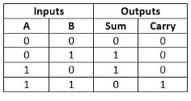  
SUM = A XOR B        CARRY = A AND B

**OUTPUT**  
  
 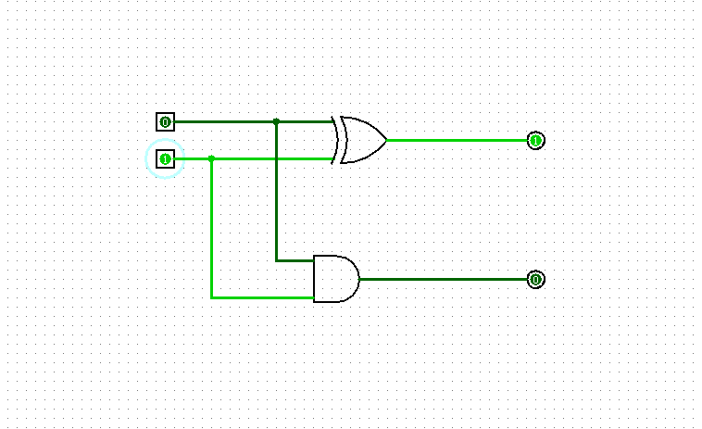  
  
  
  
**RESULT:** Thus , 2-bit half adder has been designed and implemented successfully using Logisim simulator.